Name: |  | Team Name: |  | Class:

Reflect on your experience during the Lunar Rover Research Challenge.

- What was your role in the mission?
- Navigator
- Rover Operator
- Battery Monitor
- Temperature Monitor
- Scientist

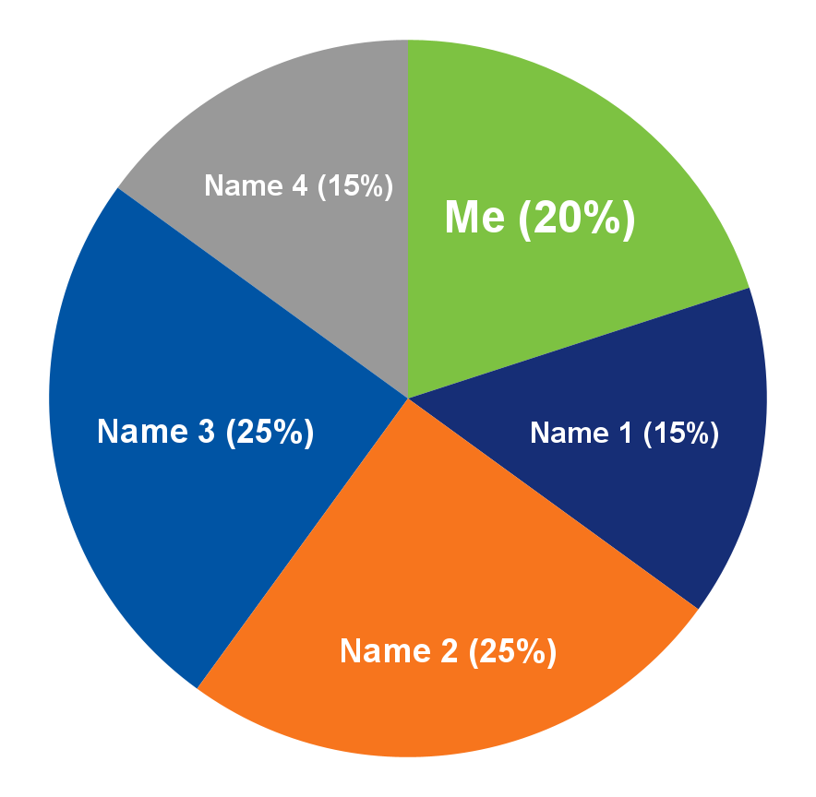
- If we made a pie chart of everyone's contributions to the mission, what would it look like? In the space provided, write each member's name, including your own. Then estimate the percentage of each person’s contribution. Make sure the total adds up to 100%.

Name | % Contribution
Total: | 100%

Title: Mission Plan Contribution Chart

3. When people collaborate on a team, some may do more work than others. Do you feel the balance on your team was fair? Please explain.

4. What went well during your mission? What tools or strategies helped your group succeed?

5. What skills did you use during this activity? Please check all that apply:

- Decision making  - Teamwork  - Communication: sharing, listening, discussing  - Creative thinking  - Critical thinking  - Design thinking  - Leading or coordinating others | - Arithmetic (adding, multiplying)  - Data recording  - Map reading  - Technical drawing  - Graphing  - Organizing  - Reading

Other:

6. Choose at least two of the skills you checked above and explain how you used them.

7. Describe one challenge you faced as an individual, or as a team. Explain how you overcame this challenge.

8. Many space careers require teamwork. What is one thing you learned about working in a team during this project?

