Overview
Your mission is to use a rover to learn about the frozen water deposits in the area around the lunar lander. To plan for future water mines, we need to know where the deposits are located, and how much water is present. Finding a source of water on the Moon is crucial to supporting humans living on the lunar surface.

As you plan your mission, consider the following factors:
- Frozen water deposits are located in the Permanently Shadowed Regions (PSRs). These are areas near the Moon’s poles that are always dark and therefore very cold.
- The lunar surface has sharp rocks, steep inclines, and loose soil called frothy regolith. The rover is at risk of getting stuck or flipping over in this hazardous terrain.
- The rover runs off a battery and is solar powered. The battery level drops in the shadows and increases in the light. If the battery runs out, the rover will shut down.
- The rover cools down in the shadows and heats up in the light. If the rover gets too cold, it will shut down.

Your team will work together to design and test a mission for your lunar rover. Each member of your team will have specific tasks to do as your rover explores. A successful mission requires everyone to work together. If you have time, plan and test more missions to see which one is best.

Your mission will use a cutting edge lunar rover developed by Canadensys Aerospace Corporation. Two scientific instruments can be added to it. Scan the QR Code to view the rover in augmented reality (AR) or visit https://qrco.de/ltcmr-en.

Mission Goal
Take measurements to gather science points while exposing the rover to the least amount of risk.

What You Need
Game Play Set (printed or Google Slides):  - Scientific Instruments  - Map of the Lunar Surface  - Rover Command Tracker  - Battery Level Tracker  - Internal Temperature Tracker  - Data Tracker  - Risk Calculator  - Mission Summary | Printed Format:  - A small object to be the rover token  - Pencil and eraser - 1 per person  - Pencil crayons or markers (optional)  Digital Format:  - One device with keyboard and internet access, per person  - A way to communicate through video, audio calls or chat, if playing remotely

Setup
- There are two versions of this game. Make sure you are using the correct Game Play Set.
Condensed Version | Full Version
Smaller map | Larger map
Action limit = 20 | Action limit = 100
Classroom use only | Use this to submit to the Lunar Rover Research Challenge

- Make sure everyone can see the Game Play Set.
- Assign roles to each group member. Each person needs to see their own Worksheet, the Instrument Cards, and the Map. The roles are as follows:
Role | Task | Worksheet
Navigator | Mark the rover’s route on the map | Map of the Lunar Surface
Rover Operator | Track the rover’s actions | Rover Command Tracker
Battery Monitor | Track the rover’s battery level | Battery Level Tracker
Temperature Monitor | Track the rover’s temperature level | Internal Temperature Tracker
Scientist | Record the location and instrument used for each measurement | Data Tracker

Combining Roles
If you are playing with fewer than five people, some people will perform more than one role. It is recommended that you combine Navigator with Scientist, and Rover Operator with the Battery Monitor and Temperature Monitor.

How to Play
Mission Criteria
For a mission to be viable, it must:
- begin with your rover on the Lander hex of the map (see map legend);
- be completed within the action limit;
- not have the battery level drop to 0%;
- not have the internal temperature drop to 0°C;
- end on a hex with no terrain risk (no mountain icon).

Each game has three phases. You must repeat each phase for each mission. Even if a mission is not viable, you must still complete all three phases.

Phase 1: Define the Mission
- As a team, choose two of the four Scientific Instruments available to add to your rover. Each instrument has three numbers for you to consider. These are the number of actions required, the percentage of battery change, and the scientific value. Scientific value contributes to the science points you will earn for your mission. Read each Instrument Card carefully, and discuss them as a team before making your decision.
- As a team, look at the map and discuss where you want to go during your mission. The map is made up of hexagonal tiles called hexes. You may want to circle an area of interest or specific hexes where you intend to take measurements.

Phase 2: Test the Mission
- Begin with your rover on the Lander hex. The battery level starts at 100%. The internal temperature starts at 30°C.
- Study the hexes around your rover.
- As a team, decide on one of the three possible actions: drive, measure, or charge-only.
- Follow the instructions for that action. *Once an action has been recorded, it cannot be undone. The team can decide to abandon the mission and restart if desired.
- Repeat steps 2 through 4 until your mission ends.

A mission ends when one of the following things happen:
- The team decides the mission is over AND all of the other mission criteria above are met. This mission is viable and can be counted for points.
- The mission exceeds the Action limit. This mission is not viable.
- The battery level drops to 0%. This mission is not viable.
- The internal temperature reaches 0°C. This mission is not viable.

Phase 3: Review the Mission
- Score your mission by calculating the total science and risk points. See Scoring Instructions below.
- Complete the Mission Summary as a team.
- If the mission is not viable: start a new mission.
If the mission is viable: decide if you are going to select this mission for your Lunar Rover Research Challenge submission (if applicable), or try another one.

Map Legend
Type of Hex | Description | Symbol
Light Hex | The white hexes on the map represent regions where there is sunlight. The rover’s battery level and internal temperature increase in light hexes.
Shadow Hex | The shaded (grey) hexes represent Permanently Shadowed Regions (PSRs). The rover’s battery level and internal temperature decrease in shadow hexes. Frozen water is more likely to be found here.
Inaccessible Hex | The hexes with a mountain range symbol and an X represent areas the rover cannot enter. This is because of extreme terrain conditions.
Lander Hex | The hex with the lander icon represents where the rover has landed on the Moon’s surface. This is where your rover starts the mission. There is only one lander hex on the map. | 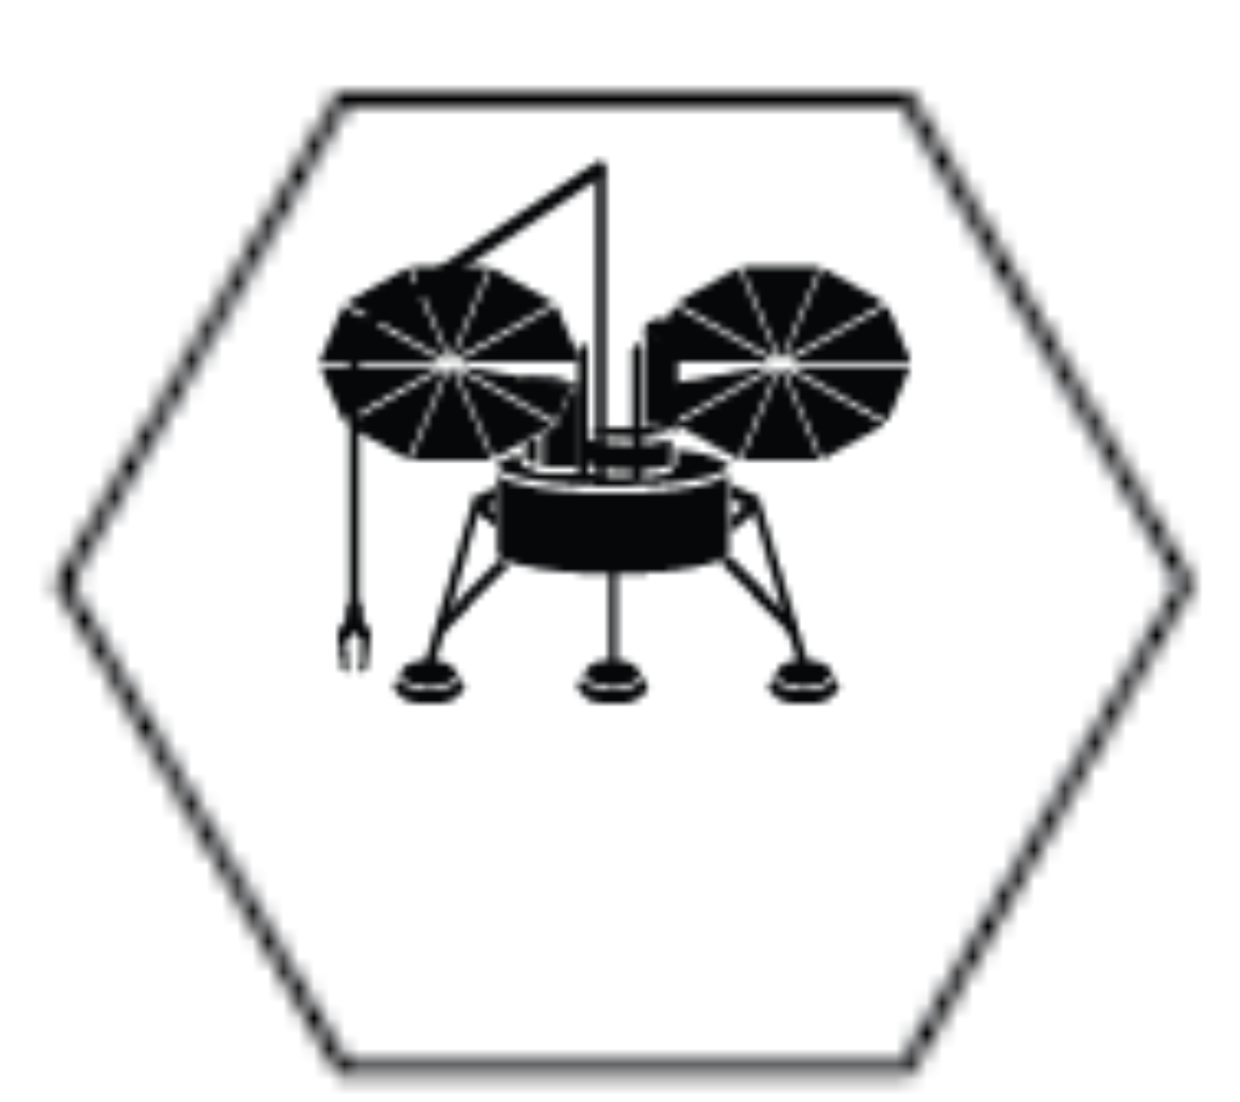

The light and shadow hexes can have three different characteristics, represented by the symbols below. These are: terrain risk, water potential, and a coordinate.

Hex Characteristic | Description | Symbol
Terrain Risk | The mountain icon(s) on a hex indicate how dangerous the terrain is. The number of icons (0, 1, or 2) equals the number of terrain risk points for that hex.  At the end of your game, you will add up all the terrain risk points along your route to calculate the total risk of your mission.
Water Potential | The snowflake icon(s) on a hex indicate how likely frozen water is to be found there. The number of icons (0, 1, or 2) equals the amount of water potential for that hex.  At the end of your game, the water potential where you take measurements will increase the science points you earn for your mission.
Coordinate | The letter and number pair used to identify each hex on the map. | A1

Drive Instructions  As a team, decide where to move your rover. Your rover can move one hex in any direction. | ➜
Rovers can drive in light or shadow hexes.
The Rover Operator records the drive symbol ➜ on the Rover Command Tracker.  Example: Drive is the second action of the mission. | 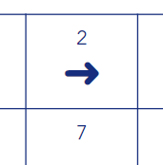
The Navigator moves the rover token to the new hex on the Map. Then they mark the route they took by drawing a line. The line will record the path the rover takes during the mission.  If playing in Google Slides, use the Curve tool to draw a line. Click on the hex to extend the line. Double click to stop drawing.  Example: In action 2, the rover moves from hex B4 to hex B5. The route so far is drawn as an orange line. The segment of the route added in action 2 is circled in blue. | 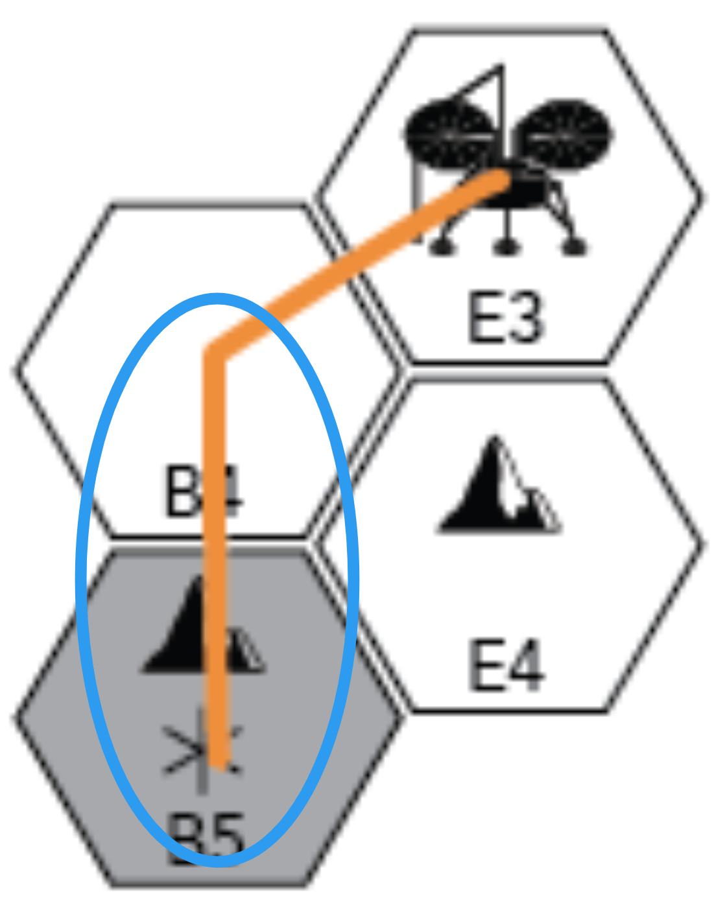
If your rover arrives in a light hex:  The Battery Monitor adds 12% to the rover’s battery level and records this new value on the Battery Level Tracker. The battery cannot charge past 100%.  If your rover arrives in a shadow hex:  The Battery Monitor subtracts 4% from the battery level and records this new value on the Battery Level Tracker. | 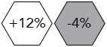
If your rover arrives in a light hex:  The Temperature Monitor adds 1°C to the internal temperature and records this new value on the Internal Temperature Tracker. If the temperature reaches 30°C, it stays at 30°C until the rover enters a shadow hex.  If your rover arrives in a shadow hex:  The Temperature Monitor subtracts 1°C from the internal temperature and records this new value on the Internal Temperature Tracker. | 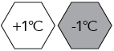

Measure Instructions  As a team, decide if you want to stop on a hex to take a measurement. Then decide which of your two instruments to use. | ✔

Measurements can only be taken in shadow hexes.

Each instrument can only be used once per hex.
The Rover Operator draws the measure symbol ✔ and the initials of the Scientific Instrument on the Rover Command Tracker for the action(s). The number of action spaces filled in will depend on the instrument used. This information is listed on the Instrument Card.  Example: The neutron spectrometer uses two actions, in this case, actions 4 and 5 of the mission. | 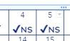
The Battery Monitor reads the battery change per action on the Scientific Instrument card. Next they calculate the new value of the battery level by applying the battery change and recording it on the Battery Level Tracker. Repeat the calculation for each action the instrument uses.  Example: The battery was at 96% before this measurement (action 3). The neuron spectrometer has a battery change of -8% per action and it uses two actions. The final battery level is 80%. | 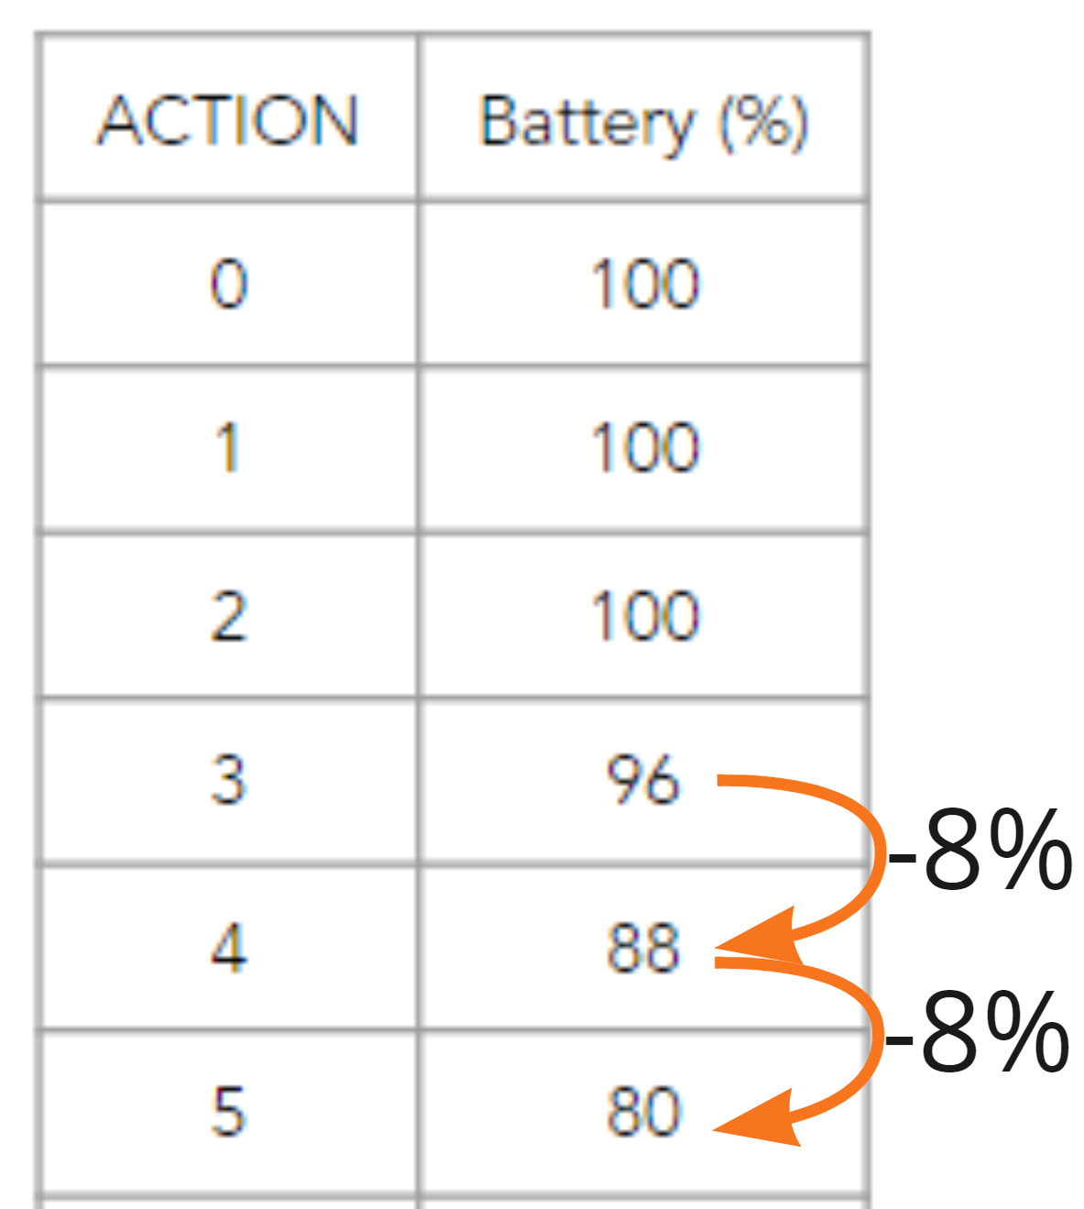
The Temperature Monitor subtracts 1°C from the temperature and records the new temperature on the Internal Temperature Tracker. They repeat this calculation for each action the instrument uses. | 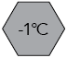  per action
The Scientist reads the coordinate and water potential () on the map. They record this location information on the Data Tracker. Next, they read the initials and scientific value (🔎) on the Scientific Instrument card and record this instrument information on the Data Tracker. Finally, they calculate the science points of the measurement by multiplying the water potential by the scientific value.  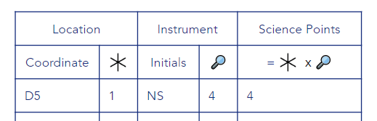 | Example: The neutron spectrometer was used on hex D5. The water potential of this location (1), multiplied by the scientific value of this instrument (4), equals 4 science points.

Charge-Only Instructions  As a team, decide if you want to stop on a hex to charge the rover’s battery by 20%. | ✖
Rovers can only charge in light hexes.
The Rover Operator draws the charge symbol ✖ on the Rover Command Tracker for the action. | 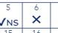
The Battery Monitor adds 20% to the battery level and records this new value on the Battery Level Tracker.  The battery cannot be charged past 100%. | 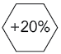
The Temperature Monitor adds 1°C to the internal temperature and records this new value on the Internal Temperature Tracker.  If the temperature reaches 30°C, it stays at 30°C until the rover enters a shadow hex. | 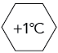

SCORING INSTRUCTIONS  Calculate the mission’s total science and risk points. | Trackers for Reference
The Scientist calculates the total science points of the mission by adding up the science points of each measurement on the Data Tracker. | 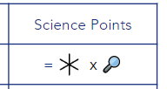
The Battery Monitor counts up the number of actions the rover completed in the danger zone. This is when the battery level is 20% or less. It is represented by a red area on the Battery Level Tracker. The Battery Monitor records this number on the Risk Calculator.  Example: The rover completed three actions in the danger zone. | 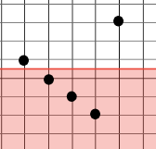
The Temperature Monitor counts up the number of actions the rover completed in the danger zone. This is when the rover’s internal temperature is lower than 5°C. It is represented by the blue area on the Internal Temperature Tracker. The Temperature Monitor records this number on the Risk Calculator.  Example: The rover completed five actions in the danger zone. | 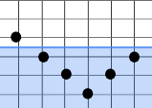
The Navigator counts up the total terrain risk of the mission by adding up the terrain risk points of every hex along the rover’s route. They record this number on the Risk Calculator.

The risk of a hex is only counted once per visit. If your rover completes several actions in a row, on the same hex, the risk is only counted once.
The Rover Operator completes the Risk Calculator to determine the total risk. They do this by adding the systems risk and the terrain risk together. | 